Enterprise Network Design and Administration
Building a Secure Enterprise LAN using
Windows Server 2022 and Cisco Packet Tracer

Project Documentation
Ashish Pathak

Network Engineering Portfolio

July 2026

1.Executive Summary
The Enterprise Network Design and Administration project was developed to simulate a real-world enterprise network environment using Windows Server 2022 and Cisco Packet Tracer. The primary objective of this project was to design, configure, and validate a secure, scalable, and centrally managed network infrastructure that reflects common practices used in modern organizations.

The project demonstrates the deployment of Windows Server 2022 as the primary Domain Controller with Active Directory Domain Services (AD DS), Domain Name System (DNS), Dynamic Host Configuration Protocol (DHCP), and Group Policy Objects (GPO). Organizational Units (OUs), domain users, security groups, shared folders, and NTFS permissions were configured to implement centralized identity management, resource access control, and administrative policies.

On the networking side, Cisco Packet Tracer was used to design the enterprise network topology. Virtual Local Area Networks (VLANs) were implemented to logically separate server and client networks, while Router-on-a-Stick technology enabled inter-VLAN communication. Additional network services such as trunking, IP addressing, DHCP integration, and network connectivity testing were configured to ensure reliable communication between network devices.

Comprehensive validation was performed using connectivity tests, DNS resolution, DHCP lease verification, Active Directory authentication, Group Policy enforcement, and shared resource accessibility. The successful completion of these tests confirmed that the implemented infrastructure operates as an integrated enterprise network.

This project strengthened practical skills in Windows Server administration, enterprise network design, Cisco networking fundamentals, troubleshooting, and system documentation. It serves as a portfolio project demonstrating the ability to design, implement, secure, and validate an enterprise network environment using industry-relevant technologies.

2. Project Objective

- To design and implement a secure and scalable enterprise network infrastructure using Windows Server 2022 and Cisco Packet Tracer.
- To deploy and configure Active Directory Domain Services (AD DS) for centralized authentication, authorization, and user management.
- To configure Domain Name System (DNS) services for reliable hostname resolution within the enterprise network.
- To implement Dynamic Host Configuration Protocol (DHCP) for automatic IP address allocation and centralized network configuration.
- To create and manage Organizational Units (OUs), domain users, security groups, and administrative policies using Active Directory.
- To configure shared folders and implement NTFS and Share permissions for secure resource access.
- To design a segmented network using Virtual Local Area Networks (VLANs) to improve security and network organization.
- To configure trunk links and Router-on-a-Stick for communication between multiple VLANs.
- To implement Group Policy Objects (GPOs) for centralized management of user and computer configurations.
- To perform connectivity, DNS, DHCP, Active Directory, and resource access testing to validate the functionality of the enterprise network.
- To develop troubleshooting skills by identifying and resolving configuration and connectivity issues encountered during implementation.
- To document the complete network architecture, configuration process, testing methodology, and project outcomes following professional engineering documentation practices.

3. Technology Used

Technology / Software | Version | Purpose
Windows Server 2022 | 2022 | Configured as the Domain Controller to provide Active Directory Domain Services (AD DS), DNS, DHCP, Group Policy, and centralized user management.
Windows 10/11 Client | Windows 10/11 | Joined to the Active Directory domain to verify authentication, Group Policy application, DNS resolution, DHCP configuration, and resource access.
VMware Workstation Pro | Latest Stable Version | Used to create and manage virtual machines for the Windows Server and client systems.
Cisco Packet Tracer | 8.x | Used to design the enterprise network topology, configure routers and switches, implement VLANs, trunking, and inter-VLAN routing.
Active Directory Domain Services (AD DS) | Windows Server Role | Used for centralized authentication, authorization, user management, and domain administration.
Domain Name System (DNS) | Windows Server Role | Provided hostname resolution for devices and services within the enterprise network.
Dynamic Host Configuration Protocol (DHCP) | Windows Server Role | Automatically assigned IP addresses and network configuration to client devices.
Group Policy Management (GPO) | Windows Server Feature | Applied centralized security settings, user restrictions, and administrative policies across the domain.
NTFS & Share Permissions | Windows Server | Controlled access to shared folders and implemented role-based resource permissions.
Cisco Router | Cisco Packet Tracer | Configured Router-on-a-Stick, inter-VLAN routing, DHCP relay (if implemented), and gateway services.
Cisco Switch | Cisco Packet Tracer | Configured VLANs, access ports, trunk ports, and Layer-2 switching between network devices.
Command Prompt (CMD) | Windows | Used for testing network connectivity, DNS resolution, DHCP configuration, and domain communication using commands such as ping, ipconfig, nslookup, gpresult, and net use.

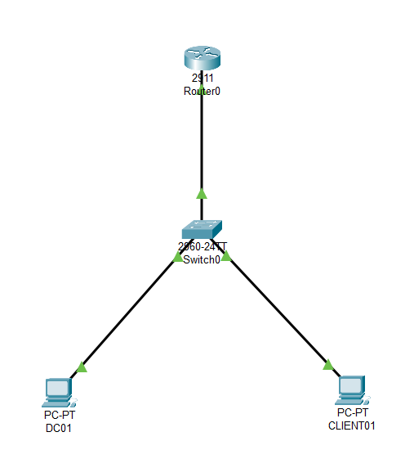

Figure 4.1: Enterprise Network Topology Designed in Cisco Packet Tracer

4. System Requirements

Hardware Requirements

Component | Minimum Requirement | Recommended
Processor | Intel Core i5 (6th Generation or Higher) / AMD Ryzen 5 | Intel Core i7 / AMD Ryzen 7
RAM | 8 GB | 16 GB or Higher
Storage | 50 GB Free Disk Space | 100 GB SSD
Network | Standard Ethernet/Wi-Fi Adapter | Gigabit Ethernet

Software Requirements

Software | Purpose
Windows 11 | Host Operating System
VMware Workstation Pro | Virtualization platform for Windows Server and Client virtual machines
Windows Server 2022 | Domain Controller providing AD DS, DNS, DHCP, and Group Policy services
Windows 10/11 | Client operating system joined to the Active Directory domain
Cisco Packet Tracer (Version 8.x or later) | Network topology design and Cisco router/switch configuration
Microsoft Remote Desktop (Optional) | Remote administration of virtual machines
Command Prompt (CMD) | Network troubleshooting and verification
PowerShell | Windows Server administration and management
Active Directory Users and Computers | User, Group, and Organizational Unit management
DNS Manager | DNS zone and record management
DHCP Manager | DHCP scope and lease management
Group Policy Management Console (GPMC) | Creation and administration of Group Policy Objects

Network Requirements

- Domain Name: lab.local
- Domain Controller IP Address: 192.168.10.10
- DNS Server: 192.168.10.10
- DHCP Scope: 192.168.10.100 – 192.168.10.200
- Default Gateway: Configured on the Cisco Router
- VLAN 10: Server Network
- VLAN 20: Client Network

Virtual Machines Used

Virtual Machine | Operating System | Purpose
DC01 | Windows Server 2022 | Active Directory Domain Controller, DNS, DHCP, Group Policy
CLIENT01 | Windows 10/11 | Domain-Joined Client used for testing authentication, policies, and network connectivity

Network Devices

Device | Quantity | Purpose
Cisco Router | 1 | Inter-VLAN Routing and Default Gateway
Cisco 2960 Switch | 1 | VLAN and Layer-2 Switching
Windows Server | 1 | Domain Services
Windows Client | 1 | Enterprise Client

6. Network Architecture

Overview

The enterprise network architecture was designed to simulate a real-world organizational environment using Windows Server 2022 and Cisco Packet Tracer. The infrastructure provides centralized user authentication, network management, IP address allocation, hostname resolution, and secure communication between multiple network segments.
The network consists of a Windows Server 2022 Domain Controller (DC01), a domain-joined Windows client (CLIENT01), a Cisco router, and a Cisco Layer-2 switch. The Windows Server hosts Active Directory Domain Services (AD DS), DNS, DHCP, and Group Policy services, while the Cisco devices provide VLAN segmentation and inter-VLAN routing.
The network is logically divided into two Virtual Local Area Networks (VLANs):
- VLAN 10 (Servers): Hosts the Windows Server 2022 Domain Controller and enterprise services such as Active Directory, DNS, and DHCP.
- VLAN 20 (Clients): Hosts client computers that obtain network configuration automatically, join the Active Directory domain, and access centralized enterprise resources.
Communication between VLANs is achieved using the Router-on-a-Stick technique, where a single physical connection between the router and switch carries multiple VLANs through IEEE 802.1Q trunking. This allows clients in different VLANs to communicate securely while maintaining logical network separation.
The overall architecture follows common enterprise networking practices by combining centralized directory services with VLAN-based network segmentation, resulting in improved scalability, security, and ease of administration.

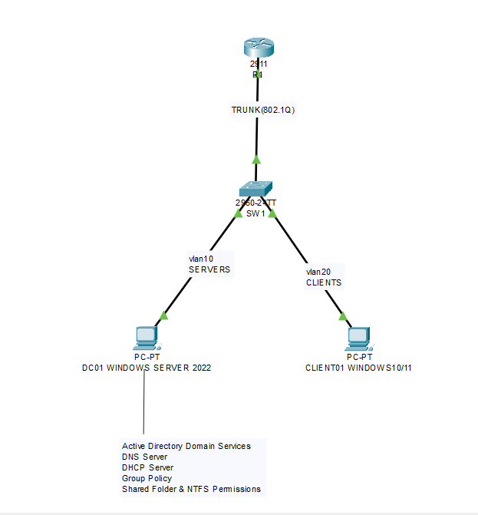
Figure 6.1: Enterprise Network Architecture

Network Components

The enterprise network consists of the following components:
Cisco Router (R1):
Acts as the default gateway for all VLANs and performs inter-VLAN routing using Router-on-a-Stick. The router also provides network connectivity between different logical segments.
Cisco Layer-2 Switch (SW1):
Connects all end devices and implements VLAN segmentation. The switch is configured with access ports for end devices and a trunk port connecting to the router.
Windows Server 2022 (DC01):
Functions as the Domain Controller and hosts Active Directory Domain Services (AD DS), DNS, DHCP, Group Policy Management, Organizational Units, user accounts, security groups, and shared folders.
Windows Client (CLIENT01):
Represents an enterprise workstation that joins the Active Directory domain, receives network configuration through DHCP, authenticates using domain credentials, and accesses shared enterprise resources.

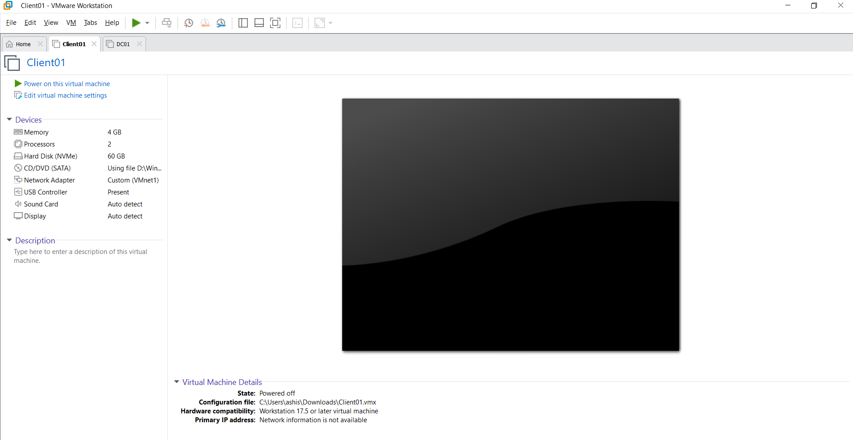

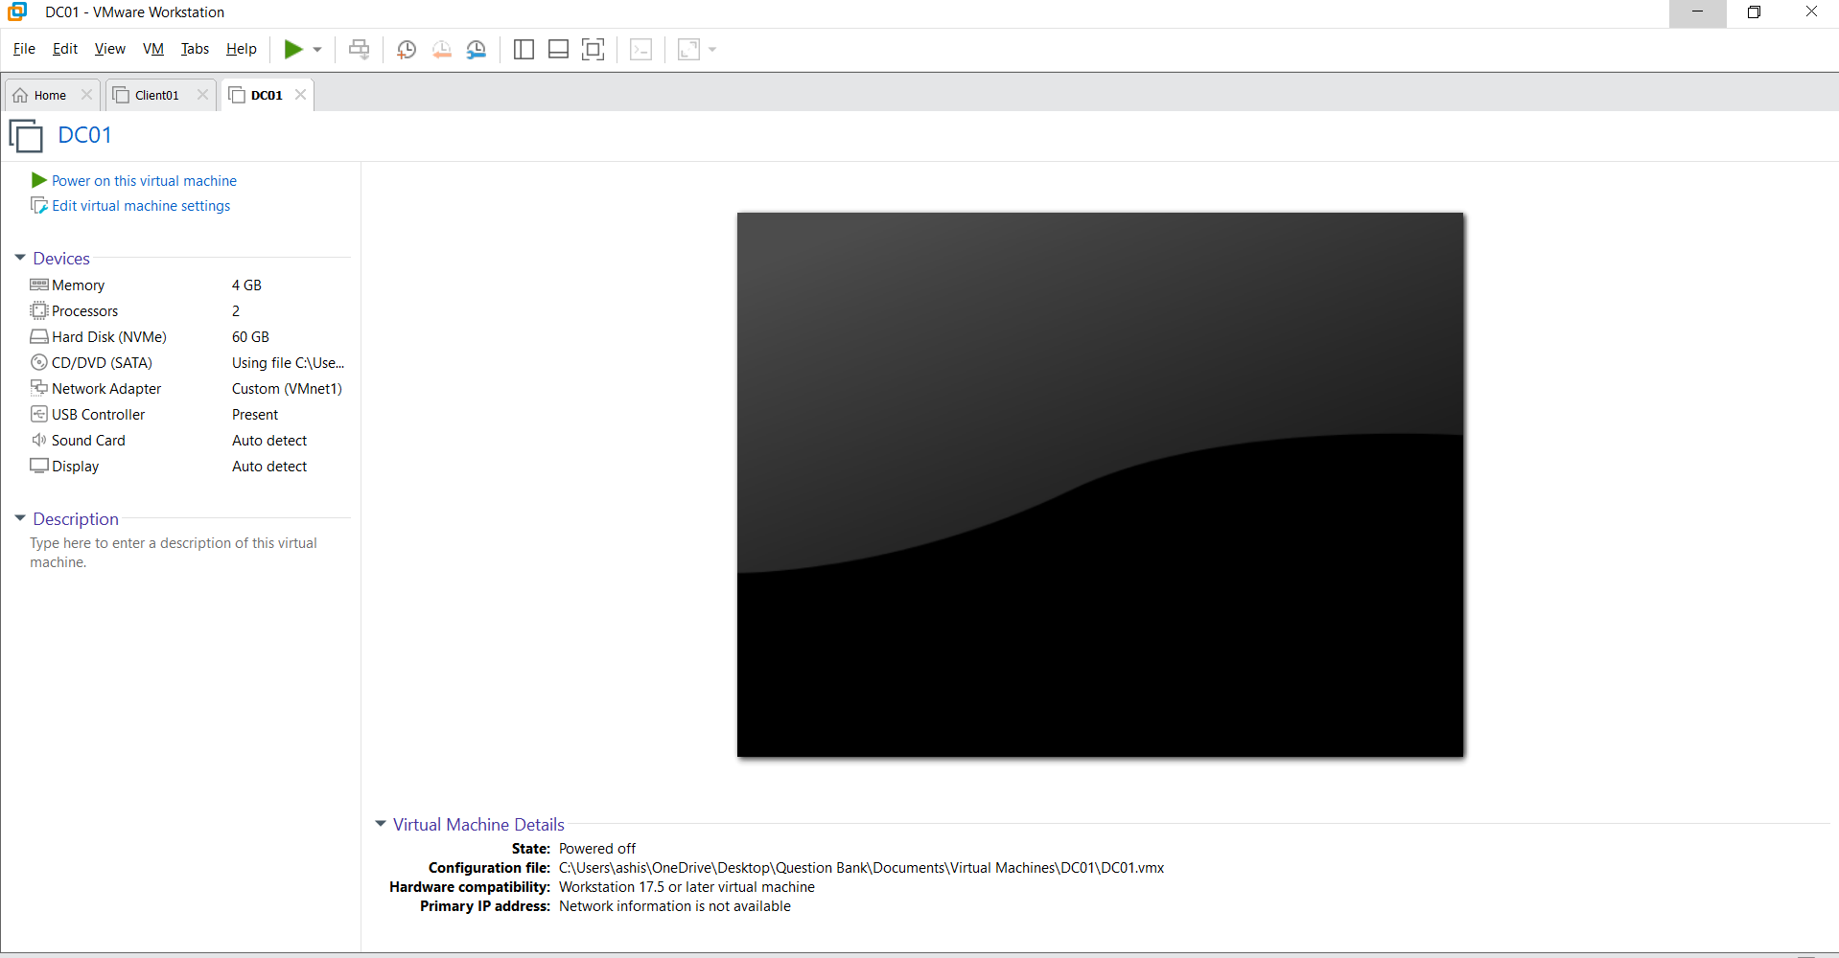
Figure 6.2,6.3 VMware Workstation

IP Addressing Scheme
Network Addressing Plan
The enterprise network is divided into two VLANs, each assigned a dedicated IPv4 subnet. VLAN 10 is used for server infrastructure, while VLAN 20 is designated for client systems. A Cisco router performs inter-VLAN routing using the Router-on-a-Stick technique, allowing communication between the two networks.
IP Address Allocation
Device | Interface | VLAN | IP Address | Subnet Mask | Default Gateway
Router (R1) | G0/0.10 | VLAN 10 | 192.168.10.1 | 255.255.255.0 | N/A
Router (R1) | G0/0.20 | VLAN 20 | 192.168.20.1 | 255.255.255.0 | N/A
DC01 (Windows Server 2022) | Ethernet | VLAN 10 | 192.168.10.10 | 255.255.255.0 | 192.168.10.1
CLIENT01 | Ethernet | VLAN 20 | DHCP / 192.168.20.100 | 255.255.255.0 | 192.168.20.1
DNS Server | DC01 | VLAN 10 | 192.168.10.10 | 255.255.255.0 | -
DHCP Server | DC01 | VLAN 10 | 192.168.10.10 | 255.255.255.0 | -
DHCP Scope
Parameter | Value
Scope Name | LabScope
Network Address | 192.168.20.0
Subnet Mask | 255.255.255.0
Address Pool | 192.168.20.100 – 192.168.20.200
Default Gateway | 192.168.20.1
DNS Server | 192.168.10.10
Domain Name | lab.local
VLAN Information
VLAN ID | VLAN Name | Purpose | Network
10 | SERVERS | Windows Server, AD DS, DNS, DHCP | 192.168.10.0/24
20 | CLIENTS | Domain-Joined Client Computers | 192.168.20.0/24


Figure 7.1 Network Topology

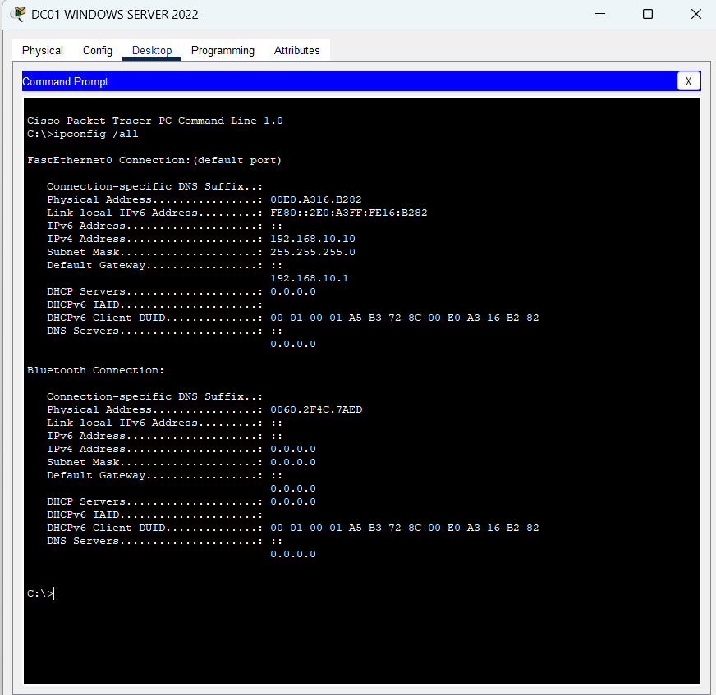
Figure 7.2: DC01 showing the server IP configuration

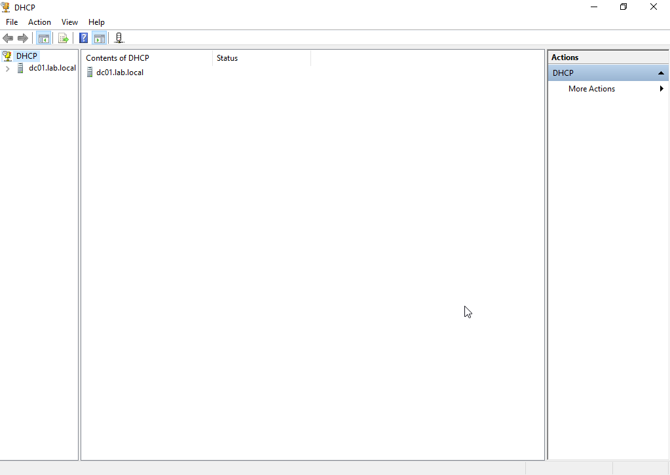

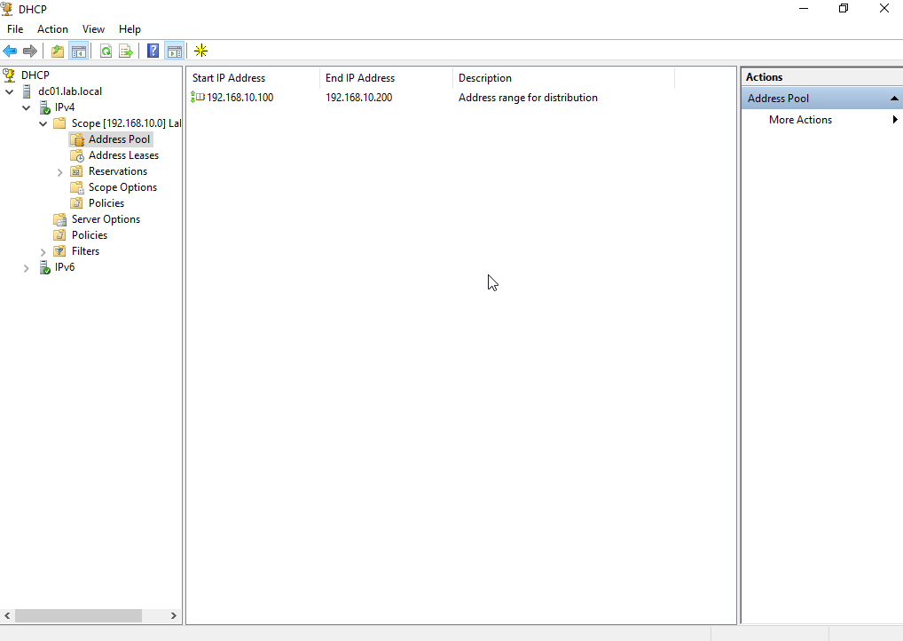

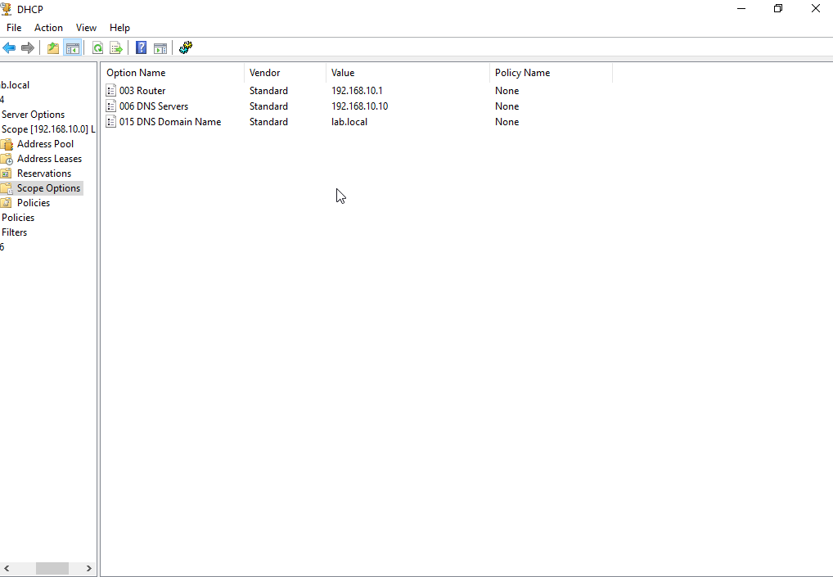

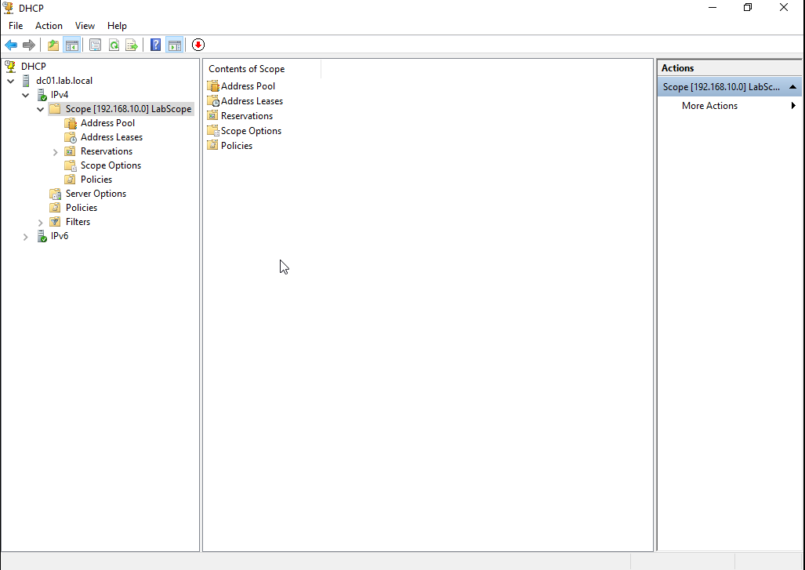
Figure 7.3: DHCP Manager showing the active scope (LabScope) and address pool.

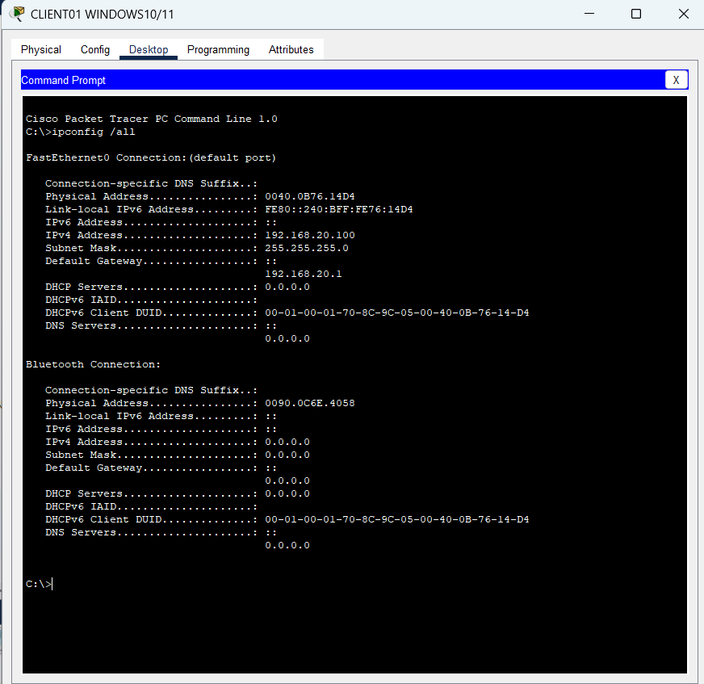
Figure 7.4: CLIENT01 showing the client IP configuration

Windows Server Configuration
Server Deployment
A virtual machine named DC01 was created using VMware Workstation Pro and installed with Windows Server 2022. The server was configured with a static IPv4 address to ensure consistent network communication and reliable operation of enterprise services.
Initial Network Configuration
The following network settings were assigned to the server:
Parameter | Value
Computer Name | DC01
Operating System | Windows Server 2022
IPv4 Address | 192.168.10.10
Subnet Mask | 255.255.255.0
Default Gateway | 192.168.10.1
Preferred DNS Server | 192.168.10.10
Domain Name | lab.local
After verifying the network configuration, the server was promoted to a Domain Controller by installing the Active Directory Domain Services (AD DS) role and creating a new Active Directory forest named lab.local.
Installed Server Roles
The following Windows Server roles were installed and configured:
- Active Directory Domain Services (AD DS)
- Domain Name System (DNS)
- Dynamic Host Configuration Protocol (DHCP)
- Group Policy Management
These services provide centralized authentication, name resolution, automatic IP address assignment, and policy-based management throughout the enterprise network.
Active Directory Deployment
A new Active Directory forest named lab.local was created during the server promotion process. Organizational Units (OUs), domain users, and security groups were configured to organize administrative resources and simplify access management.
DNS Configuration
The DNS Server role was configured to host the lab.local forward lookup zone. Host (A), Alias (CNAME), and Pointer (PTR) records were created to enable hostname resolution within the enterprise environment.
DHCP Configuration
The DHCP Server role was configured to automatically assign IPv4 addresses to client systems. A DHCP scope named LabScope was created, defining the address pool, subnet mask, default gateway, DNS server, and domain name distributed to clients.
Group Policy Configuration
Group Policy Objects (GPOs) were created to centrally manage user and computer settings across the domain. Administrative restrictions and security policies were successfully applied to domain-joined client systems.
Shared Resource Configuration
A shared folder was created on the server with both Share Permissions and NTFS Permissions configured. Access to shared resources was controlled through Active Directory security groups, demonstrating role-based access management within the enterprise network.

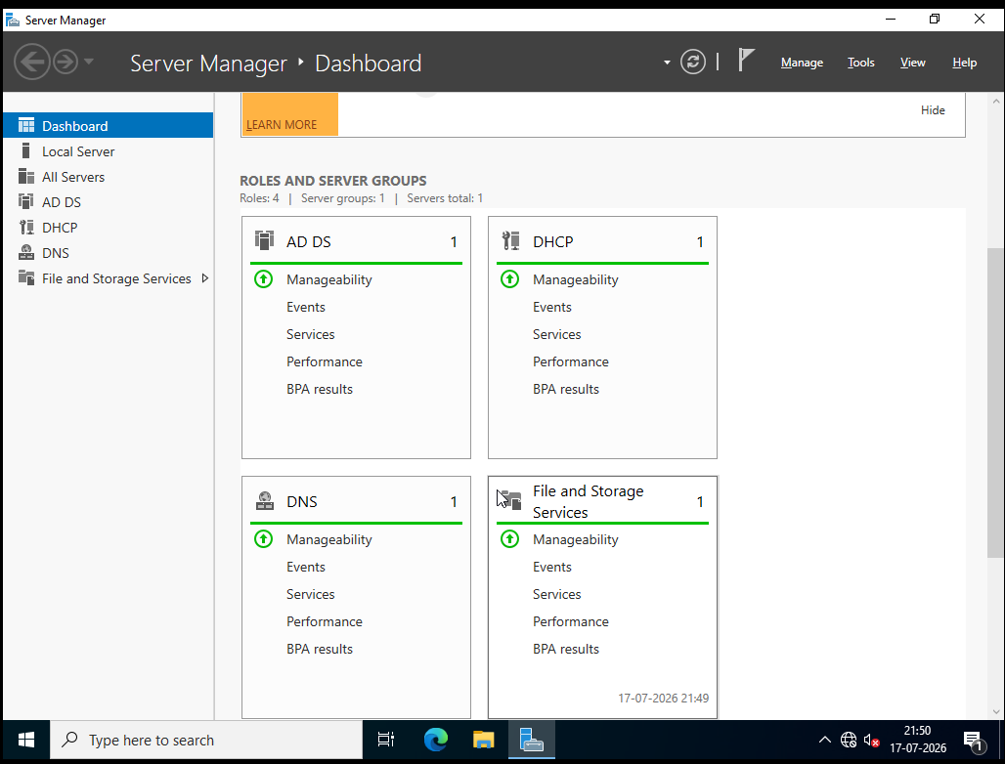
Figure 8.1 Server Manager Dashboard

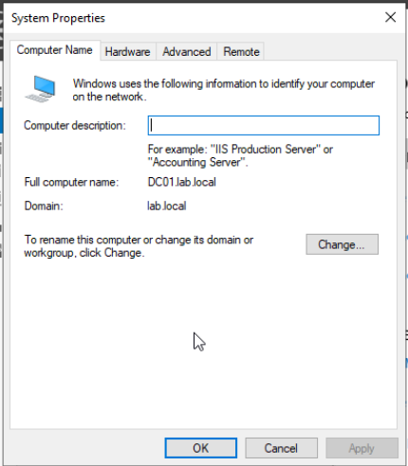
Figure 8.2 System Properties

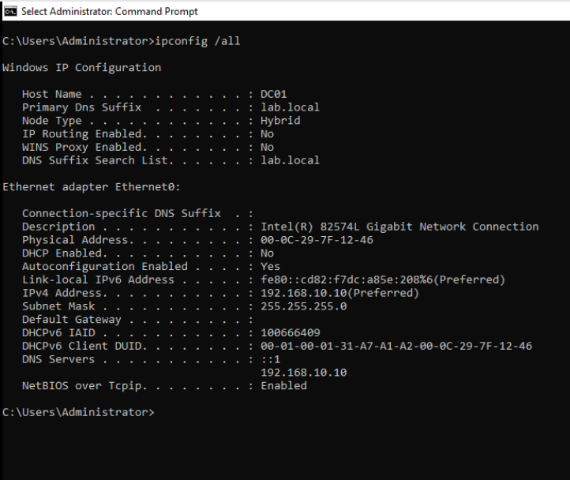
Figure 8.3 Shows Static IP, DNS Server, Gateway
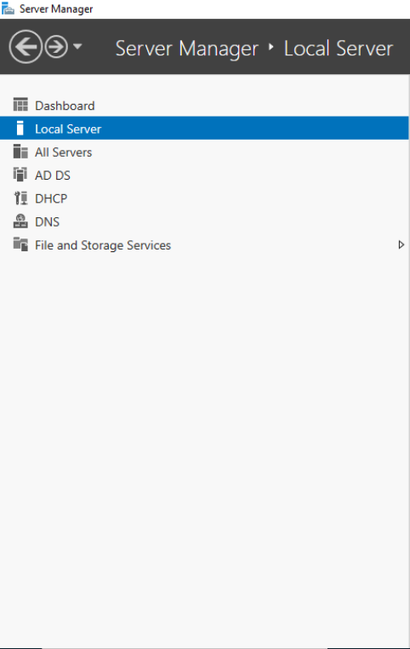
Figure 8.4 Add Roles and Features

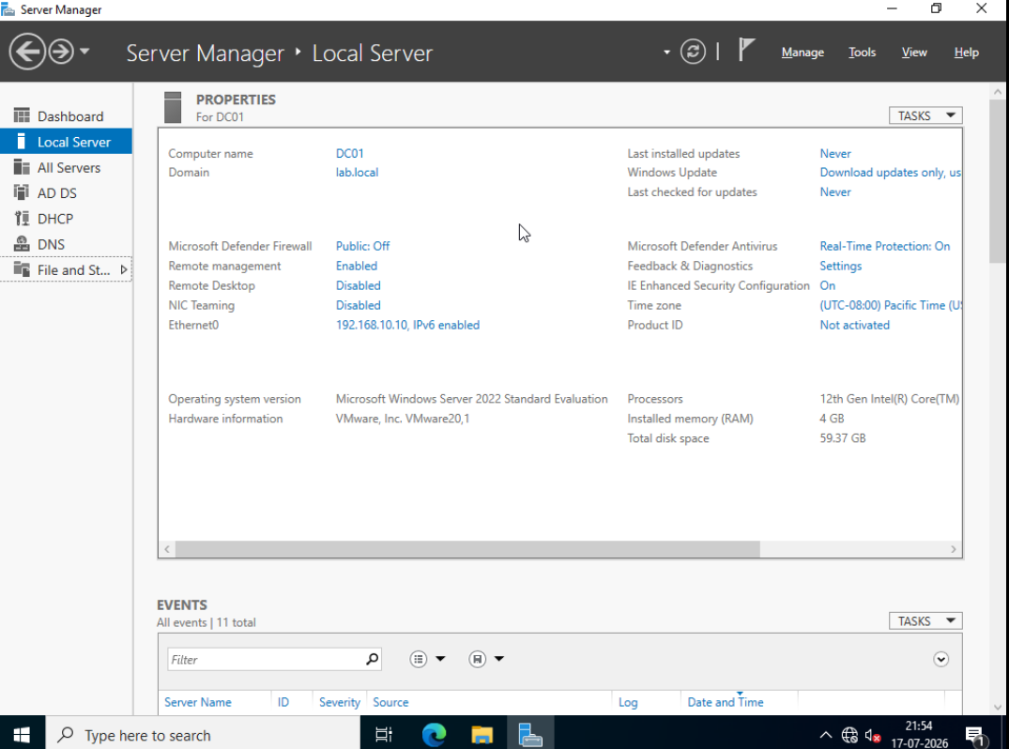

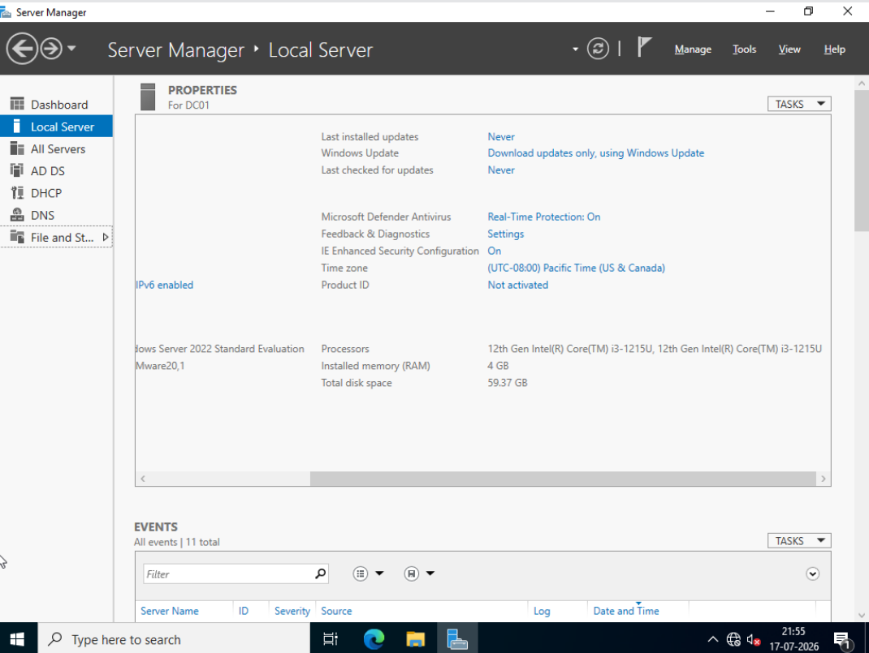
Figure 8.5 Local Server

Active Directory Configuration
Active Directory Domain Services (AD DS) was implemented to provide centralized identity management, authentication, authorization, and administration within the enterprise network. By deploying a domain controller, users, computers, and network resources can be managed from a single location, improving security, scalability, and administrative efficiency.

Overview
Active Directory Domain Services (AD DS) was deployed on the Windows Server 2022 system (DC01) to establish a centralized directory service for the enterprise network. The server was promoted to a Domain Controller by creating a new Active Directory forest named lab.local. The Active Directory environment enables centralized management of users, computers, security groups, and organizational resources while providing secure authentication and authorization throughout the domain.

Domain Information
Parameter | Value
Domain Name | lab.local
Domain Controller | DC01
Forest Functional Level | Windows Server 2022 (Default)
Domain Functional Level | Windows Server 2022 (Default)

Organizational Units (OUs)
To organize administrative resources efficiently, Organizational Units (OUs) were created within the domain. OUs allow administrators to logically group users, computers, and security groups while enabling the application of Group Policies to specific departments.
Example Organizational Units:
- IT
- HR
- Finance
- Computers
- Servers

Domain Users
Domain user accounts were created to simulate employees within the organization. Each user account is centrally managed through Active Directory, allowing authentication from any domain-joined computer.
Example User Accounts:
Username | Department
Ashish | IT
TestUser | HR

Security Groups
Security groups were created to simplify permission management for shared resources and administrative tasks.
Example Groups:
Group Name | Purpose
IT_Users | Access to IT shared resources
HR_Users | Access to HR resources
Domain Admins | Administrative privileges
Users were added to the appropriate security groups based on their roles within the organization.

Domain Join
The client computer (CLIENT01) was successfully joined to the lab.local domain. After joining the domain, users were able to authenticate using their domain credentials and receive centralized policies from the Domain Controller.

Active Directory Features Implemented
The following Active Directory features were successfully configured:
- Active Directory Domain Services (AD DS)
- Organizational Units (OUs)
- Domain User Accounts
- Security Groups
- Domain Authentication
- Centralized User Management
- Group Membership Management
- Domain-Joined Client Management
The successful implementation of these features provides centralized administration and forms the foundation for DNS, DHCP, Group Policy, and secure resource access throughout the enterprise network.

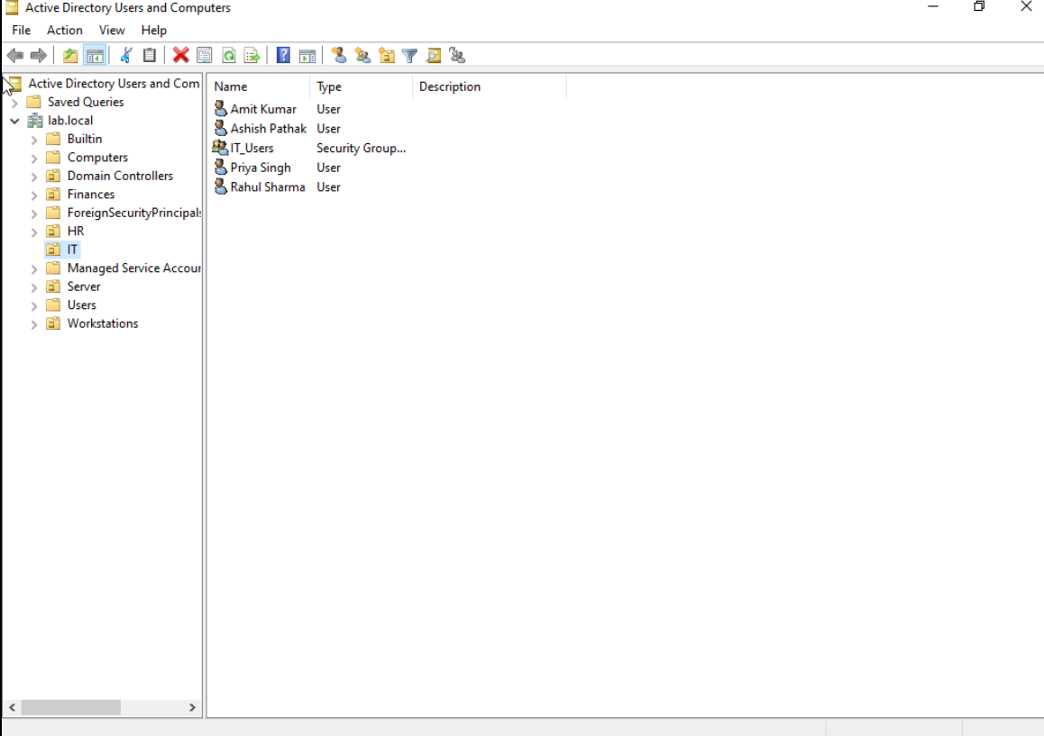
Figure 9.1: Active Directory Users and Computers Console.
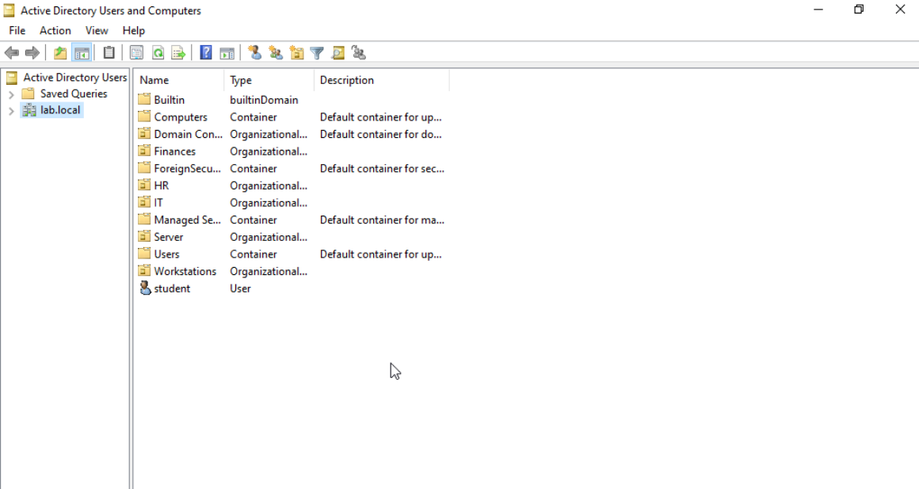
Figure 9.2: Organizational Units created within the lab.local domain.

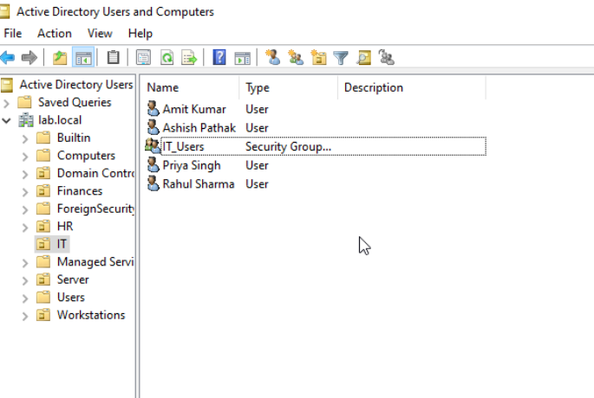
Figure 9.3: Domain user accounts within the IT Organizational Unit

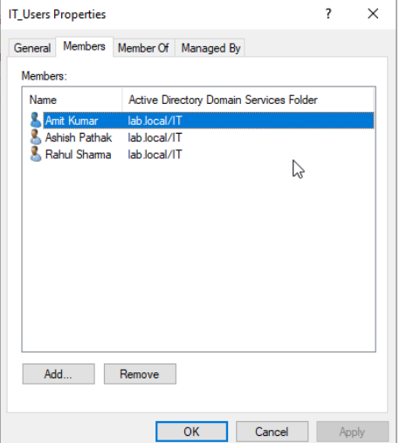
Figure 9.4: Security group membership configuration.

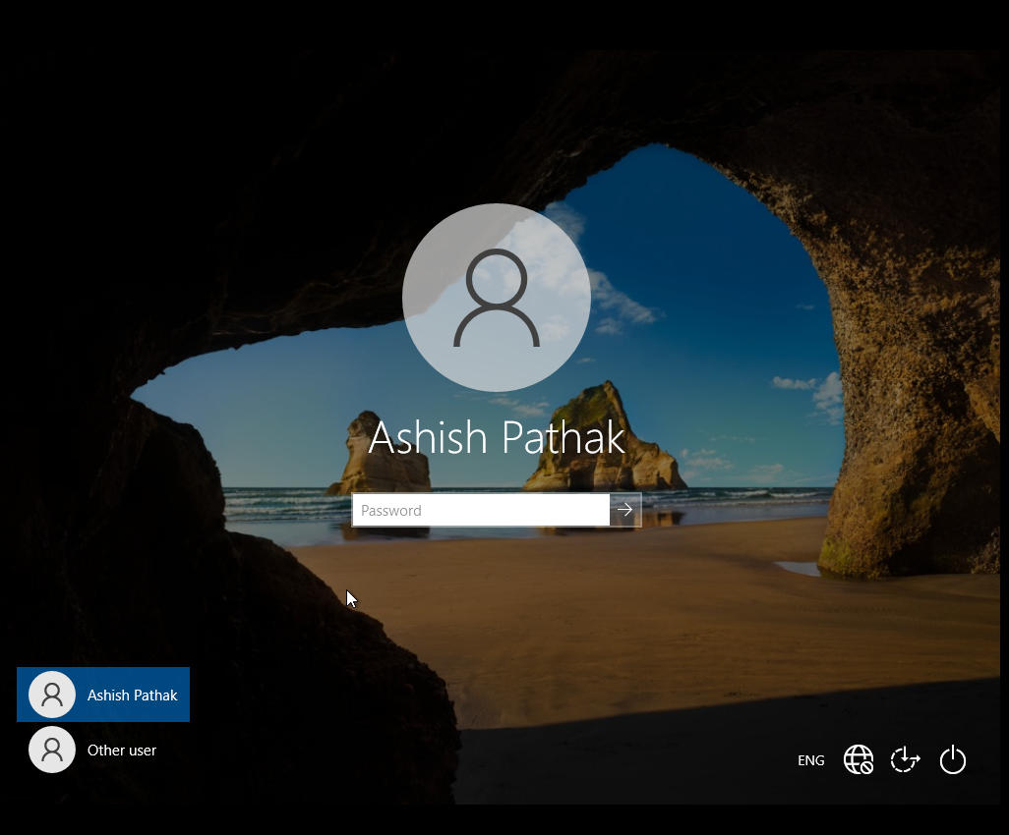
Figure 9.6: Domain user authentication using Active Directory credentials.

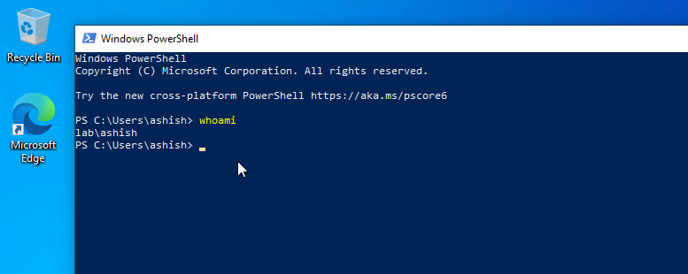
Figure 9.7: Verification of successful domain authentication.

DNS Configuration
The Domain Name System (DNS) was configured on the Windows Server 2022 Domain Controller to provide name resolution services for the enterprise network. DNS enables clients to locate domain controllers, resolve hostnames to IP addresses, and support Active Directory authentication and other network services.

Overview
The DNS Server role was installed and configured on the Domain Controller (DC01) during the deployment of Active Directory Domain Services (AD DS). A Forward Lookup Zone named lab.local was automatically created as part of the Active Directory installation, enabling centralized name resolution for all devices within the domain.To improve DNS functionality and support network administration, additional Host (A), Alias (CNAME), and Pointer (PTR) records were created. These records allow systems within the enterprise network to communicate using hostnames instead of IP addresses.

DNS Server Information
Parameter | Value
DNS Server | DC01
IP Address | 192.168.10.10
Domain Name | lab.local
DNS Zone Type | Active Directory Integrated
Dynamic Updates | Secure Only

Forward Lookup Zone
The Forward Lookup Zone lab.local stores mappings between hostnames and IPv4 addresses. During the project, the following DNS records were configured.
Host (A) Records
Host Name | IP Address | Purpose
dc01 | 192.168.10.10 | Domain Controller
fileserver | 192.168.10.50 | File Server (Simulation)

Alias (CNAME) Record
Alias | Points To
fs | fileserver.lab.local
The CNAME record allows users to access the file server using a simplified alias instead of the full hostname.

Reverse Lookup Zone
A Reverse Lookup Zone for the 192.168.10.0/24 network was created to enable reverse DNS resolution.
The following PTR record was successfully generated.
IP Address | Host Name
192.168.10.10 | dc01.lab.local
Reverse DNS resolution allows an IP address to be translated back into its corresponding hostname, which is useful for troubleshooting and network diagnostics.

DNS Testing
The DNS configuration was validated using Windows Command Prompt.
The following tests were performed successfully:
- Hostname resolution using ping
- Forward lookup using nslookup
- Reverse lookup using nslookup
- Domain name resolution for lab.local
- Verification of A, CNAME, and PTR records
The successful completion of these tests confirmed that DNS services were functioning correctly and supporting Active Directory operations.

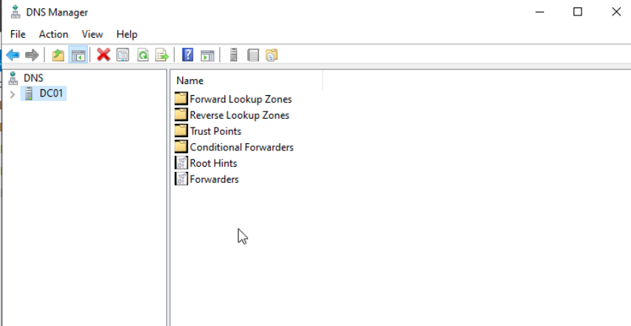
Figure 10.1: DNS Manager showing the configured DNS zones.

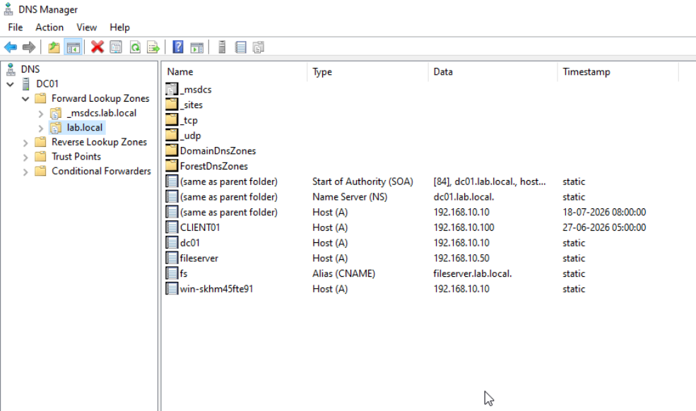
Figure 10.2: Forward Lookup Zone (lab.local) with configured DNS records.

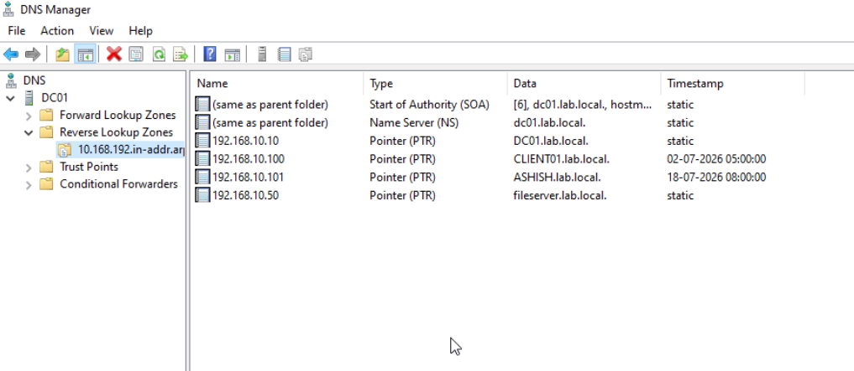
Figure 10.3: Reverse Lookup Zone containing the PTR record for the Domain Controller.

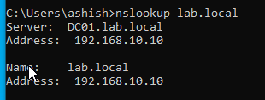
Figure 10.4: Verification of DNS resolution for the lab.local domain.

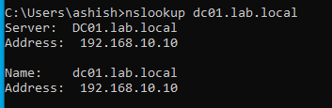
Figure 10.5: Forward DNS lookup for the Domain Controller.

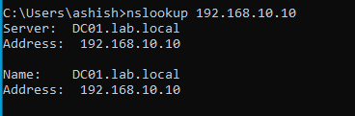
Figure 10.6: Reverse DNS lookup using the PTR record.

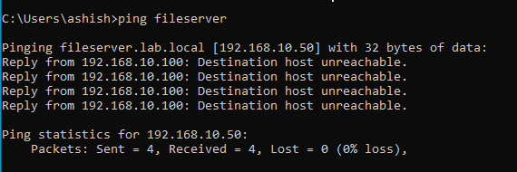
Figure 10.7: Hostname resolution using DNS A and CNAME records.
DHCP Configuration
The Dynamic Host Configuration Protocol (DHCP) service was configured on the Windows Server 2022 Domain Controller (DC01) to automate IP address allocation and simplify network administration. DHCP eliminates the need for manual IP configuration by dynamically assigning network parameters to client devices joining the enterprise network.

Overview
The DHCP Server role was installed and configured on the Domain Controller (DC01) to provide automatic IP address assignment to client computers within the enterprise network. After installation, the DHCP server was authorized in Active Directory to enable it to distribute IP addresses securely across the domain.
A DHCP scope named LabScope was created to define the IPv4 address range available for client devices. In addition to assigning IP addresses, the DHCP server provides clients with the subnet mask, default gateway, DNS server address, and domain name required for network communication.

DHCP Server Information
Parameter | Value
DHCP Server | DC01
Server IP Address | 192.168.10.10
Scope Name | LabScope
Network Address | 192.168.10.0/24
Subnet Mask | 255.255.255.0
Address Pool | 192.168.10.100 – 192.168.10.200
Lease Duration | Default
DNS Server | 192.168.10.10
Domain Name | lab.local

DHCP Scope Configuration
The DHCP scope was configured to distribute IP addresses automatically to domain-joined client computers. The address range was selected to avoid conflicts with statically assigned infrastructure devices such as the Domain Controller.
The configured DHCP scope includes:
- Scope Name: LabScope
- Start IP Address: 192.168.10.100
- End IP Address: 192.168.10.200
- Subnet Mask: 255.255.255.0
- Default Gateway: 192.168.10.1
- Preferred DNS Server: 192.168.10.10
- DNS Domain Name: lab.local

DHCP Authorization
After installing the DHCP Server role, the server was authorized in Active Directory using domain administrator credentials. This authorization ensures that only trusted DHCP servers within the Active Directory environment can distribute IP addresses to client systems.

DHCP Lease Allocation
After configuring the DHCP scope, CLIENT01 was set to obtain its network configuration automatically. Upon renewal, the client successfully received an IPv4 address from the configured DHCP address pool along with the appropriate subnet mask, default gateway, DNS server, and domain information.

DHCP Validation
The DHCP configuration was verified using the following methods:
- Verification of the configured DHCP scope
- Inspection of the configured address pool
- Review of active DHCP leases
- Client network configuration using ipconfig /all
- DHCP lease renewal using ipconfig /release and ipconfig /renew
The successful completion of these validation steps confirmed that the DHCP server was functioning correctly and providing automatic network configuration to client devices.

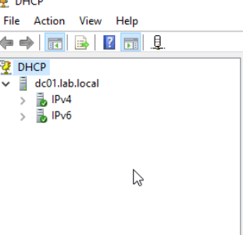
Figure 11.1: DHCP Manager displaying the configured IPv4 scope.

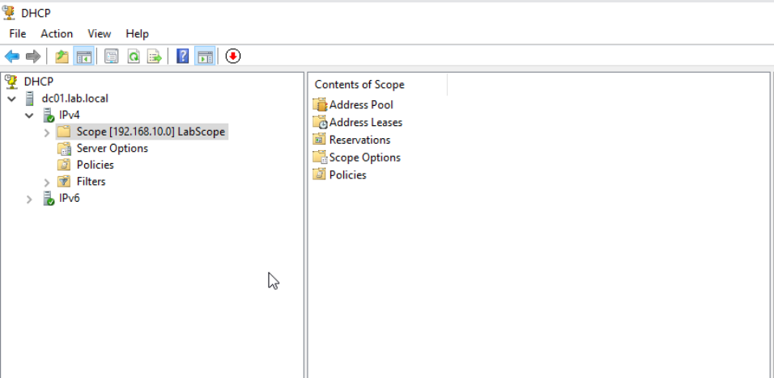
Figure 11.2: Configured DHCP Scope (LabScope).
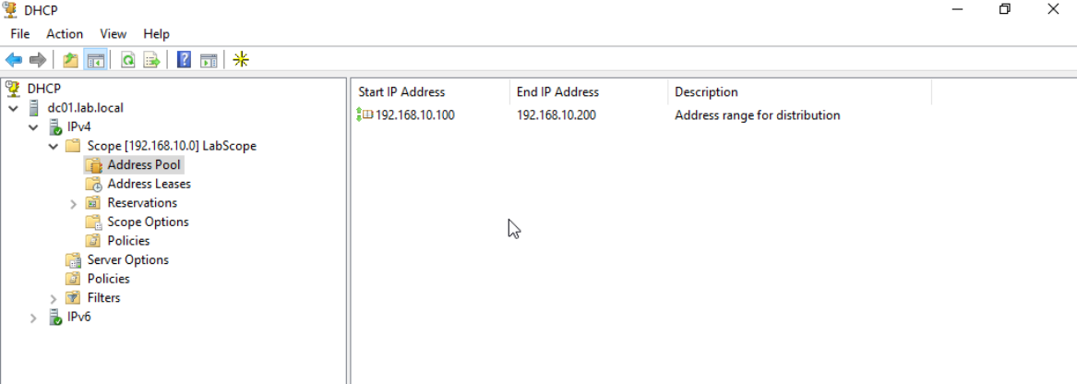
Figure 11.3: DHCP Address Pool Configuration.

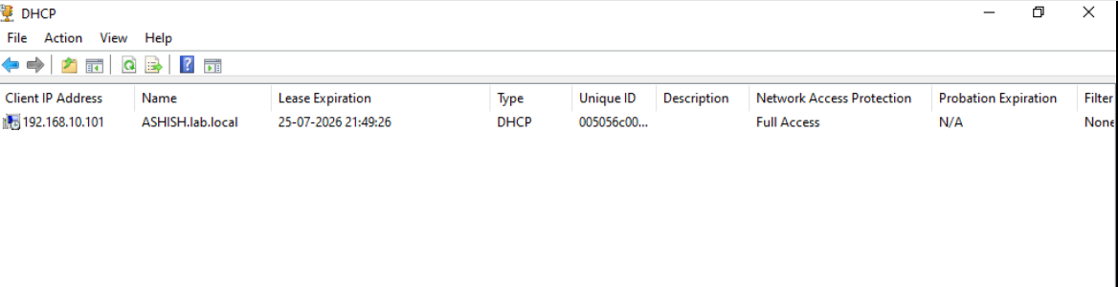
Figure 11.4: Active DHCP lease assigned to CLIENT01.

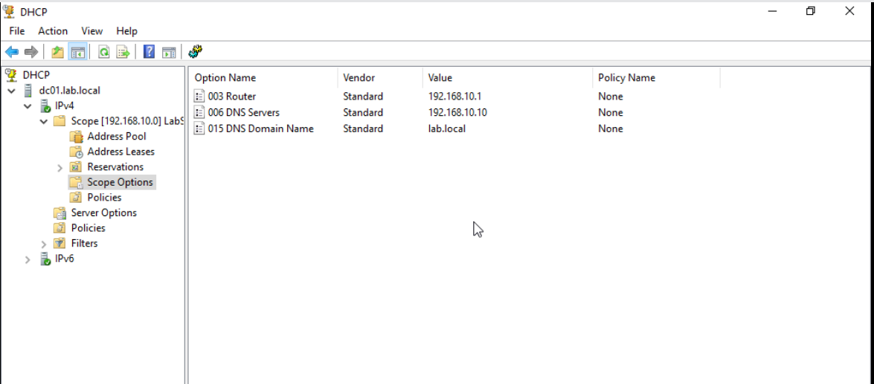
Figure 11.5: DHCP Scope Options distributed to client computers.
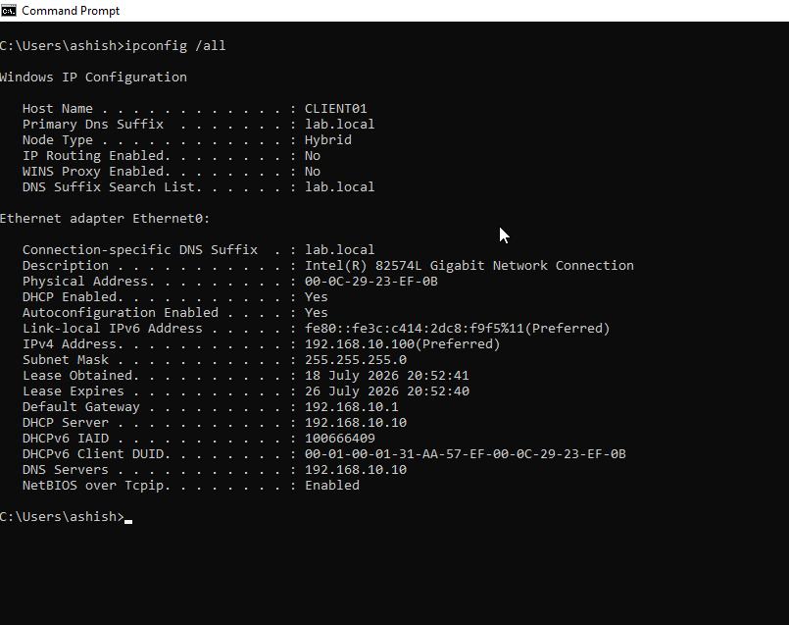
Figure 11.6: CLIENT01 receiving network configuration from the DHCP server.

Cisco Network Configuration (VLANs, Trunking, Router-on-a-Stick)

Cisco Packet Tracer was used to design and configure the network infrastructure supporting the Windows Server environment. The network was segmented using Virtual Local Area Networks (VLANs) to separate server and client traffic. A Cisco router was configured using the Router-on-a-Stick technique to provide inter-VLAN routing, allowing secure
communication between different network segments while maintaining logical isolation.

Overview
The enterprise network topology was implemented using a Cisco router and a Cisco Layer-2 switch in Cisco Packet Tracer. VLAN segmentation was used to logically separate server and client devices into different broadcast domains, improving network organization, scalability, and security. A trunk link was established between the router and switch using IEEE 802.1Q encapsulation. Router-on-a-Stick was implemented by creating multiple router sub-interfaces, each acting as the default gateway for a specific VLAN.

Network Topology
The network consists of one Cisco router (R1), one Cisco 2960 switch (SW1), one Windows Server (DC01), and one client workstation (CLIENT01). The router provides inter-VLAN routing while the switch manages Layer-2 connectivity and VLAN segmentation.

VLAN Configuration
Two VLANs were created to separate enterprise resources.
VLAN ID | VLAN Name | Purpose | Network
10 | SERVERS | Windows Server Infrastructure | 192.168.10.0/24
20 | CLIENTS | Client Computers | 192.168.20.0/24
Server systems were connected to VLAN 10, while client systems were connected to VLAN 20.

Access Port Configuration
The switch access ports were configured to assign end devices to their respective VLANs.
Switch Port | Connected Device | VLAN
FastEthernet0/2 | DC01 | VLAN 10
FastEthernet0/3 | CLIENT01 | VLAN 20

Trunk Configuration
A trunk link was configured between the Cisco router and the Cisco switch using IEEE 802.1Q trunking. The trunk port carries traffic for both VLAN 10 and VLAN 20 over a single physical connection.
Device | Interface | Mode
Router R1 | GigabitEthernet0/0 | Trunk
Switch SW1 | GigabitEthernet0/1 | Trunk

Router-on-a-Stick Configuration
Inter-VLAN routing was implemented using Router-on-a-Stick. Separate logical sub-interfaces were created on the router for each VLAN.
Sub-interface | VLAN | IP Address
GigabitEthernet0/0.10 | 10 | 192.168.10.1
GigabitEthernet0/0.20 | 20 | 192.168.20.1
Each sub-interface serves as the default gateway for devices within its VLAN.

Inter-VLAN Communication
Router-on-a-Stick enables communication between devices located in different VLANs while maintaining logical network separation.
For example:
- CLIENT01 can communicate with the Domain Controller (DC01).
- CLIENT01 can access DNS and DHCP services hosted on DC01.
- Domain authentication functions correctly across VLAN boundaries.

Verification Commands
The following Cisco IOS commands were used to verify the network configuration.
Switch Verification
- show vlan brief
- show interfaces trunk
- show running-config
Router Verification
- show ip interface brief
- show ip route
- show running-config
The successful output of these commands confirmed that VLANs, trunking, router sub-interfaces, and routing were configured correctly.

Result
The Cisco network infrastructure successfully provided:
- VLAN-based network segmentation
- IEEE 802.1Q trunking
- Inter-VLAN routing using Router-on-a-Stick
- Connectivity between server and client networks
- Support for Windows Server services such as Active Directory, DNS, and DHCP
- A scalable enterprise LAN architecture following industry-standard networking practices


Figure 12.1: Enterprise network topology designed in Cisco Packet Tracer.

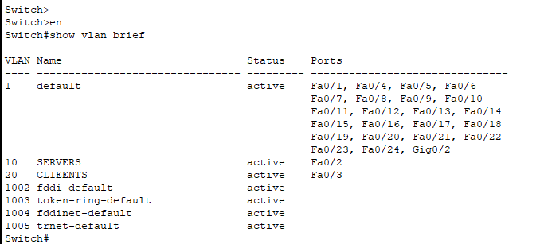
Figure 12.2: VLAN configuration on the Cisco switch.

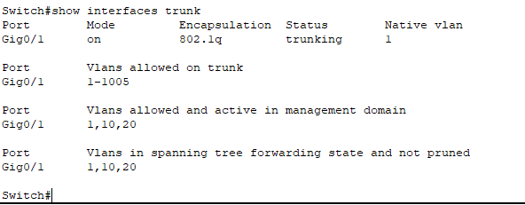
Figure 12.3: IEEE 802.1Q trunk configuration.

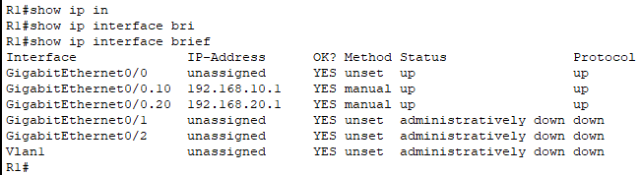
Figure 12.4: Router subinterface configuration for Router-on-a-Stick.

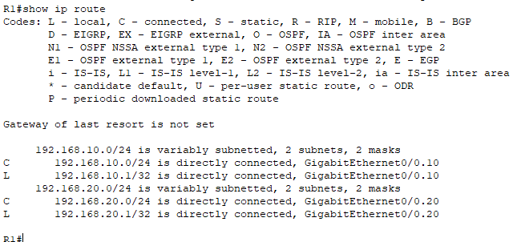
Figure 12.5: Router routing table.

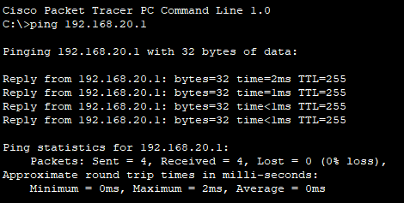
Figure 12.6: Connectivity test between CLIENT01 and its default gateway.

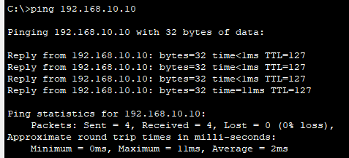
Figure 12.7: Successful communication between CLIENT01 and the Windows Server across VLANs.

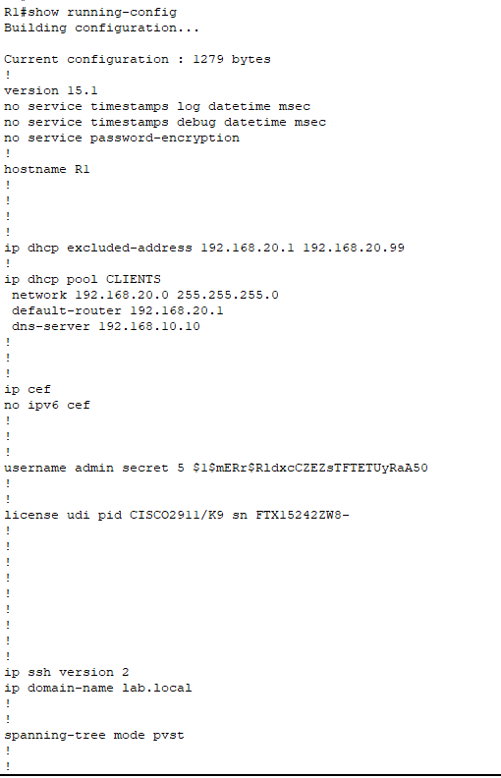
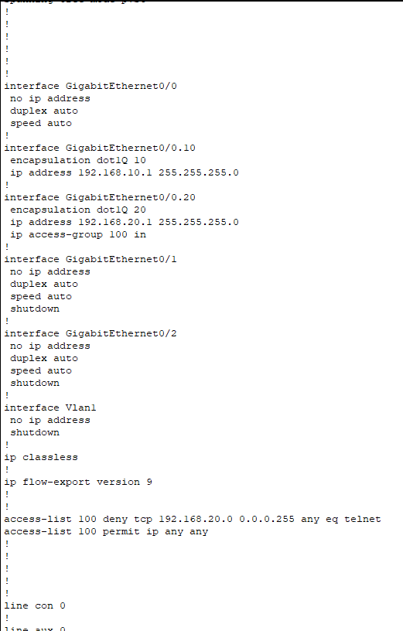
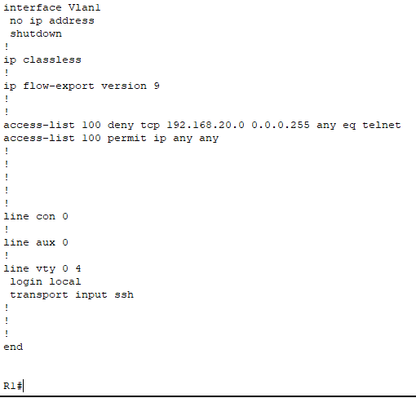
Figure 12.8: Router running configuration.
Group Policy Configuration

Group Policy Objects (GPOs) were implemented to centrally manage user and computer settings within the Active Directory domain. By applying policies through Active Directory, administrative tasks can be automated, security can be enhanced, and consistent configurations can be enforced across all domain-joined computers.

Overview
Group Policy Objects (GPOs) were configured on the Windows Server 2022 Domain Controller to centrally manage user and computer configurations within the lab.local domain. The implemented policies demonstrate how enterprise administrators can enforce security settings, restrict user access, and automate administrative tasks without requiring manual configuration on individual client systems. The Group Policy Management Console (GPMC) was used to create, edit, and link policies to the appropriate Organizational Units (OUs) within Active Directory.

Group Policy Management
The Group Policy Management Console was used to create and manage domain policies. After creating each policy, it was linked to the appropriate Organizational Unit to ensure that only the intended users or computers received the configuration.

Implemented Group Policies
Control Panel Restriction
A User Configuration policy was created to prevent users from accessing the Windows Control Panel and Settings application.
Purpose:
- Prevent unauthorized system configuration changes.
- Improve endpoint security.
- Enforce centralized administrative control.
The policy was successfully applied, and domain users were unable to access the Control Panel after logging into the domain.

Network Drive Mapping
A Group Policy Preference was configured to automatically map the shared folder \\DC01\IT_Share as drive Z: for users belonging to the appropriate Active Directory security group.
Benefits:
- Automatic resource availability after user logon.
- No manual drive mapping required.
- Centralized deployment of shared resources.

Group Policy Update
After creating or modifying Group Policies, the client computer was updated using the following command:
gpupdate /force
The command successfully refreshed both computer and user policies without requiring manual configuration.

Policy Verification
The successful application of Group Policies was verified using the following methods:
- Attempting to open the Control Panel from CLIENT01.
- Confirming the automatic mapping of the Z: network drive.
- Running gpresult /r to verify applied Group Policies.
- Logging in with a domain user account and validating policy enforcement.

Benefits of Group Policy
The implemented Group Policies provide several enterprise administration advantages:
- Centralized management of user and computer settings.
- Improved endpoint security.
- Reduced administrative effort.
- Consistent configuration across domain-joined systems.
- Automated deployment of network resources.
The successful implementation of Group Policy demonstrates the ability to centrally administer enterprise workstations using Windows Server 2022 and Active Directory.

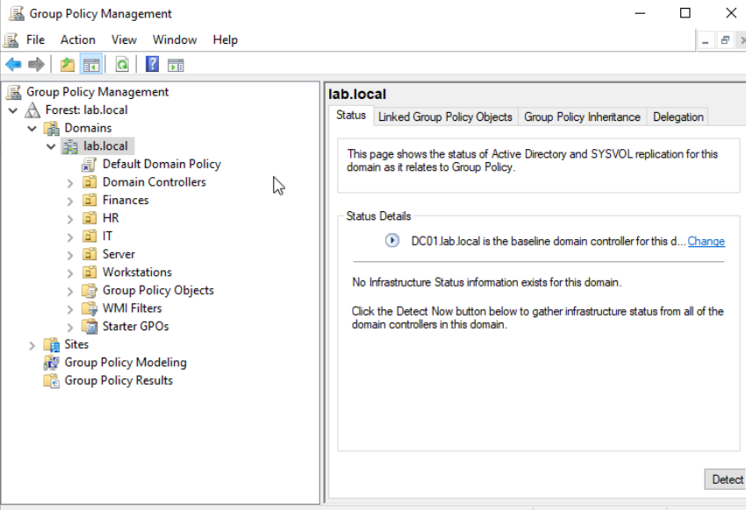
Figure 13.1: Group Policy Management Console.
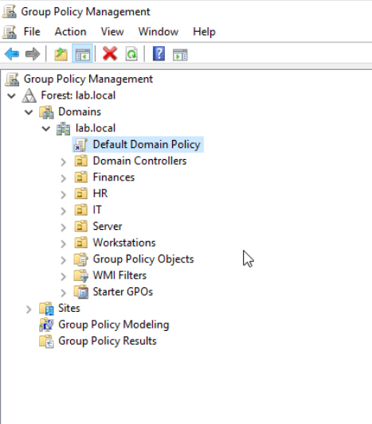
Figure 13.2: Group Policy linked to the Organizational Unit.

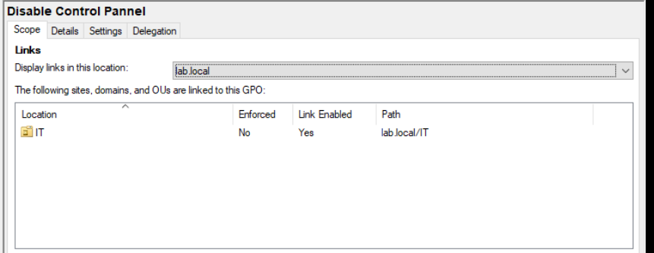

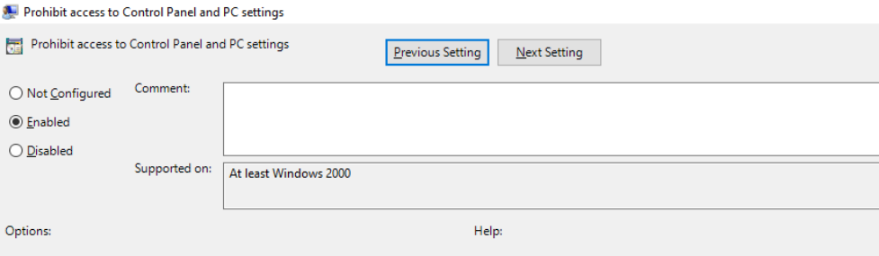
Figure 13.3: Configuration of the Control Panel restriction policy.

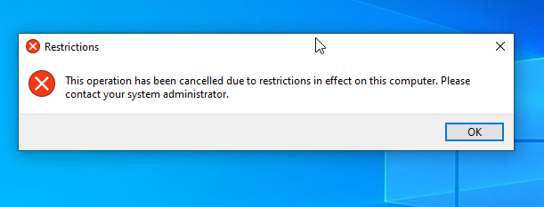
Figure 13.4: Control Panel access blocked by Group Policy.

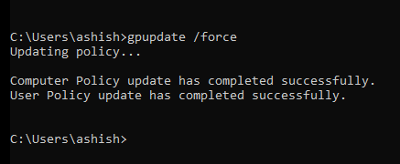
Figure 13.5: Updating Group Policy on the client computer.

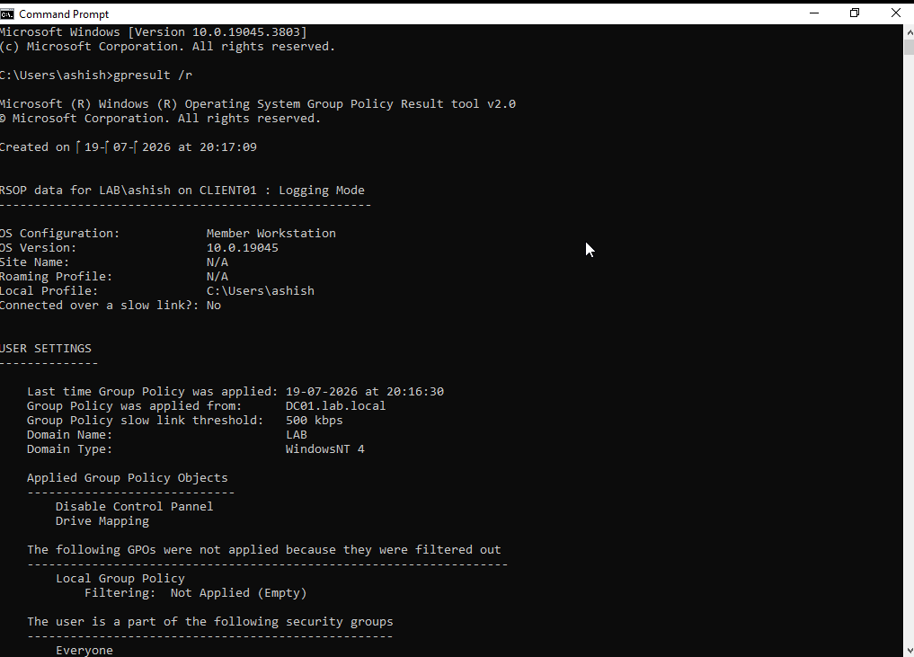

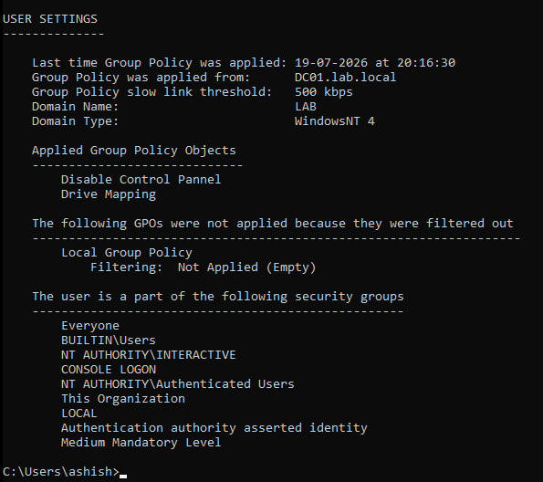
Figure 13.6: Verification of applied Group Policies using gpresult

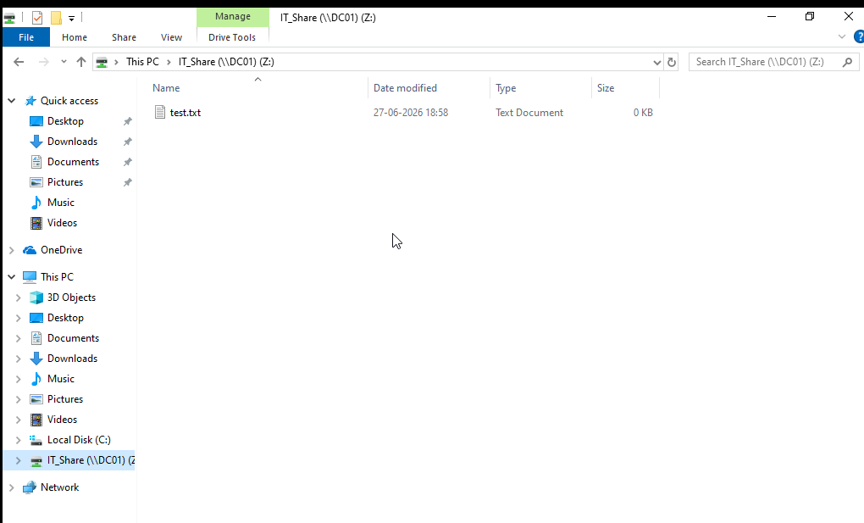
Figure 13.7: Automatically mapped network drive deployed through Group Policy.

Shared Folder & NTFS Permissions

Shared folders and NTFS permissions were configured to provide secure, role-based access to organizational resources. Access control was implemented using Active Directory security groups, allowing permissions to be managed centrally rather than assigning rights directly to individual users. This approach follows enterprise best practices by simplifying administration and improving security.

Overview
A shared folder named IT_Share was created on the Windows Server 2022 Domain Controller (DC01) to provide centralized file sharing for domain users. Access to the shared folder was controlled using both Share Permissions and NTFS Permissions, ensuring that only authorized users could access the resources.
Instead of assigning permissions directly to user accounts, Active Directory security groups were used to simplify permission management and improve scalability.

Shared Folder Configuration
The shared folder was created on the Domain Controller and shared with the following settings.
Parameter | Value
Shared Folder Name | IT_Share
Server Name | DC01
Network Path | \\DC01\IT_Share
Share Type | SMB File Share

Share Permissions
Share permissions determine what users can do when accessing the folder over the network.
The following permissions were configured:
Security Principal | Permission
IT_Users | Change, Read
Administrators | Full Control
The default Everyone group was removed to prevent unauthorized access.

NTFS Permissions
NTFS permissions provide file system-level security and work together with Share Permissions to control access.
The following permissions were configured:
Security Principal | Permission
IT_Users | Modify
Administrators | Full Control
SYSTEM | Full Control
Inheritance was disabled where necessary to allow customized permissions for the shared folder.

Security Group Implementation
A security group named IT_Users was created within Active Directory.
Domain users requiring access to the shared folder were added to this group. Permissions were assigned to the group rather than individual user accounts, following the principle of role-based access control (RBAC).
This approach simplifies administration because future users only need to be added to the appropriate security group to inherit the required permissions.

Shared Folder Access
The shared folder was successfully accessed from CLIENT01 using a domain user account.
A network drive (Z:) was automatically mapped through Group Policy to provide seamless access to the shared resource after user logon.

Verification
The shared folder configuration was validated using the following tests:
- Verification of Share Permissions.
- Verification of NTFS Permissions.
- Successful access to \\DC01\IT_Share from CLIENT01.
- Successful automatic mapping of the Z: drive through Group Policy.
- Verification that authorized users could create, modify, and delete files within the shared folder.
The successful completion of these tests confirmed that the shared folder was securely configured and accessible only to authorized domain users.

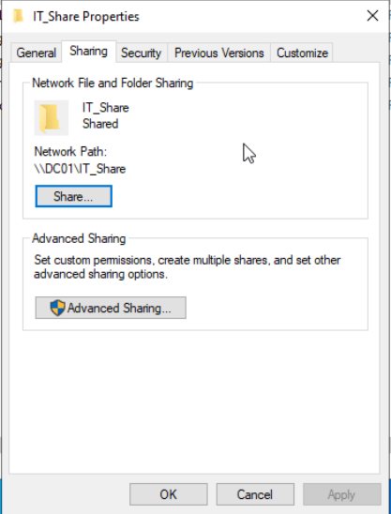
Figure 14.1: Shared folder configuration for IT_Share.

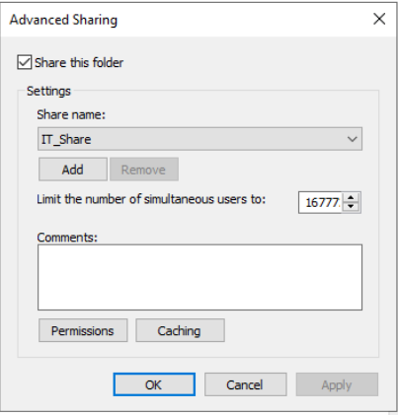
Figure 14.2: Advanced Sharing configuration.

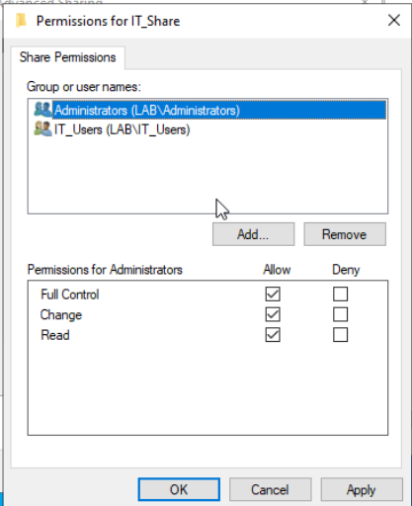
Figure 14.3: Share permissions configured for IT_Share.

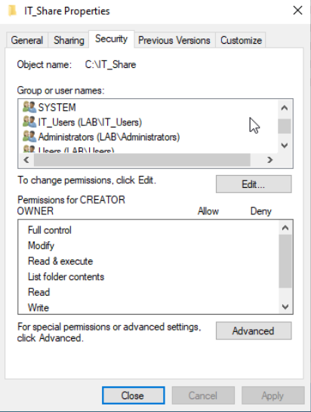
Figure 14.4: NTFS permissions assigned to the shared folder.

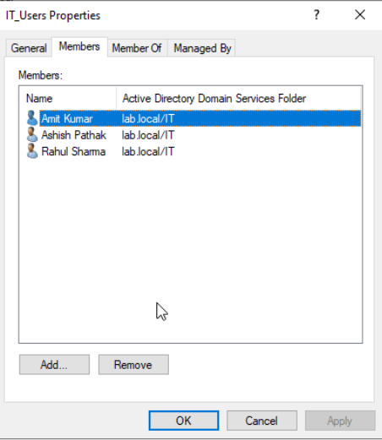
Figure 14.5: Active Directory security group used for access control.

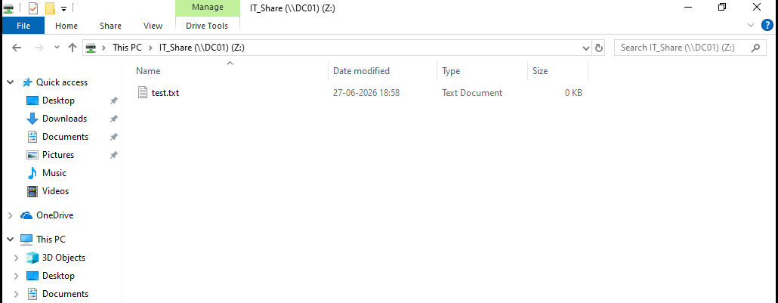
Figure 14.6: Successful access to the shared folder from a domain-joined client

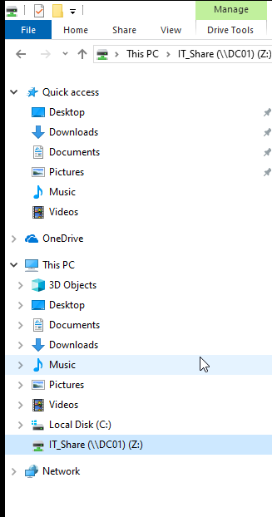
Figure 14.7: Network drive automatically mapped using Group Policy.
.
Testing and Validation

After completing the configuration of the enterprise network infrastructure, a series of functional tests were performed to verify the correct operation of Windows Server services, Active Directory, DNS, DHCP, Group Policy, file sharing, and network connectivity. The objective of these tests was to ensure that all services operated together as an integrated enterprise environment.

Overview
A comprehensive testing process was conducted to validate the functionality of the enterprise network environment. Each configured service was tested individually and then verified as part of the complete infrastructure to ensure reliable communication, centralized management, and secure resource access.

Test Summary
Test ID | Test Description | Expected Result | Status
TC-01 | Verify Client receives IP address from DHCP | Client receives valid IP address automatically | Passed
TC-02 | Verify Domain Join | CLIENT01 successfully joins lab.local | Passed
TC-03 | Verify Domain Login | Domain user successfully authenticates | Passed
TC-04 | Verify DNS Name Resolution | Hostnames resolve correctly | Passed
TC-05 | Verify Reverse DNS Lookup | PTR record resolves correctly | Passed
TC-06 | Verify Active Directory Users | Domain users authenticate successfully | Passed
TC-07 | Verify Group Policy Application | Configured policies applied to client | Passed
TC-08 | Verify Shared Folder Access | Authorized users access IT_Share | Passed
TC-09 | Verify Network Drive Mapping | Z: drive mapped automatically | Passed
TC-10 | Verify Network Connectivity | Successful communication between devices | Passed

Test Case 1 – DHCP Verification
Objective:
Verify that CLIENT01 receives its network configuration automatically.
Procedure:
- Configure CLIENT01 to obtain an IP address automatically.
- Execute:
ipconfig /all
Expected Result:
- DHCP Enabled = Yes
- IP Address assigned from LabScope
- DNS Server = 192.168.10.10
- Correct Default Gateway
Actual Result:
CLIENT01 successfully obtained network settings from the DHCP server.
Status: Passed

Test Case 2 – Active Directory Authentication
Objective:
Verify domain authentication.
Procedure:
Login using:
LAB\Ashish
Expected Result:
Successful authentication.
Actual Result:
User logged into the Active Directory domain successfully.
Status: Passed

Test Case 3 – DNS Verification
Objective:
Verify DNS functionality.
Procedure:
Execute:
nslookup dc01.lab.local
Expected Result:
Returns:
192.168.10.10
Actual Result:
DNS resolved successfully.
Status: Passed

Test Case 4 – Reverse Lookup
Procedure:
nslookup 192.168.10.10
Expected Result:
dc01.lab.local
Actual Result:
PTR record resolved correctly.
Status: Passed

Test Case 5 – Group Policy Verification
Objective:
Verify that Group Policy has been applied.
Procedure:
- Execute:
gpupdate /force
- Execute:
gpresult /r
- Attempt to open Control Panel.
Expected Result:
Control Panel access blocked.
Actual Result:
Group Policy applied successfully.
Status: Passed

Test Case 6 – Shared Folder Access
Objective:
Verify secure access to shared resources.
Procedure:
Open:
\DC01\IT_Share
Expected Result:
Authorized users can access the folder.
Actual Result:
Folder opened successfully.
Status: Passed

Test Case 7 – Network Drive Mapping
Objective:
Verify automatic drive mapping.
Procedure:
Log into CLIENT01.
Expected Result:
Drive Z: appears automatically.
Actual Result:
Drive mapped successfully.
Status: Passed

Test Case 8 – Network Connectivity
Objective:
Verify communication between enterprise devices.
Procedure:
Execute:
ping dc01.lab.local
ping fileserver
Expected Result:
Replies received successfully.
Actual Result:
Connectivity verified.
Status: Passed

Overall Result
All planned validation tests were completed successfully. The Windows Server 2022 infrastructure, Active Directory Domain Services, DNS, DHCP, Group Policy, shared folders, and Cisco network components functioned together as an integrated enterprise network. The testing process confirmed that the environment met the project objectives and demonstrated the successful implementation of centralized authentication, automated IP address allocation, name resolution, policy enforcement, secure file sharing, and reliable network connectivity.


Figure 15.1 ipconfig /all on CLIENT01 showing DHCP configuration


Figure 15.2 Domain login using LAB\Ashish

Figure 15.3 nslookup dc01.lab.local


Figure 15.4 nslookup 192.168.10.10 (PTR lookup)




Figure 15.5 gpresult /r showing applied GPOs


Figure 15.6 Control Panel restriction message


Figure 15.7 \\DC01\IT_Share opened from CLIENT01


Figure 15.8 Mapped Z: drive

Figure 15.9 ping fileserver (or ping 192.168.10.50) showing successful replies


Figure 15.10 DHCP Address Leases showing CLIENT01
Challenges Encountered and Troubleshooting

During the implementation of the enterprise network, several configuration and connectivity issues were encountered. Each issue was analyzed using standard troubleshooting techniques, and appropriate corrective actions were taken. Resolving these challenges improved the reliability and functionality of the overall network environment while strengthening practical troubleshooting skills.

Overview
The deployment of the enterprise network required troubleshooting multiple issues related to Windows Server configuration, Active Directory, DNS, DHCP, Group Policy, and shared resources. The following table summarizes the key challenges encountered and the corresponding solutions implemented.

Troubleshooting Summary
Issue | Cause | Resolution
Client could not join the domain | Incorrect DNS configuration | Configured CLIENT01 to use DC01 (192.168.10.10) as the preferred DNS server and verified domain connectivity.
Domain user account was disabled | User account was disabled in Active Directory | Enabled the user account in Active Directory Users and Computers and verified successful login.
DHCP client did not receive an IP address | DHCP scope or client configuration issue | Verified the DHCP scope, activated it, and configured CLIENT01 to obtain an IP address automatically.
DNS name resolution failed | Missing or incorrect DNS records | Created and verified A, CNAME, and PTR records using DNS Manager and validated them with nslookup.
Reverse DNS lookup failed | Reverse Lookup Zone was not configured | Created a Reverse Lookup Zone and verified PTR record resolution.
Internet DNS forwarding did not work | The virtual environment used Host-Only networking without Internet access | Recognized that external DNS forwarding requires NAT or Bridged networking. Internal DNS functionality remained operational.
Group Policy was not applied | Policy update had not yet occurred | Executed gpupdate /force and verified policy application using gpresult /r.
Control Panel restriction initially did not work | GPO was not linked or updated | Linked the GPO to the correct Organizational Unit, refreshed policies, and confirmed successful enforcement.
Unable to modify NTFS permissions | Permission inheritance was enabled | Disabled inheritance on the shared folder and configured custom NTFS permissions.
Shared folder access failed | Incorrect Share or NTFS permissions | Assigned permissions to the IT_Users security group and verified access from CLIENT01.

Troubleshooting Methodology
The following tools and techniques were used throughout the project:
- Ping for connectivity testing.
- ipconfig /all to verify network configuration.
- nslookup for DNS verification.
- gpupdate /force to refresh Group Policies.
- gpresult /r to verify applied policies.
- Active Directory Users and Computers for account management.
- DNS Manager for record verification.
- DHCP Manager for scope and lease validation.
- Event Viewer for reviewing Windows Server events when required.

Lessons Learned
The troubleshooting process provided practical experience in diagnosing and resolving common enterprise networking issues. It reinforced the importance of proper DNS configuration for Active Directory, correct DHCP scope configuration, accurate permission management, and systematic verification after every configuration change. The project also highlighted the value of structured troubleshooting using built-in Windows administrative tools.




Figure 16.1 gpresult /r showing applied Group Policies


Figure 16.2 nslookup dc01.lab.local after fixing DNS


Figure 16.3 DHCP Address Leases showing CLIENT01 received an IP address

Figure 16.4 Shared Folder permissions (Security or Sharing tab) after correcting NTFS permissions
Future Enhancements

While the current implementation successfully provides a functional enterprise network environment, several additional features and technologies can be integrated in the future to improve scalability, security, automation, and fault tolerance.

Conclusion

This project successfully demonstrated the design, implementation, and validation of a Windows Server 2022–based enterprise network integrated with Cisco networking technologies. A complete lab environment was built using VMware Workstation Pro and Cisco Packet Tracer to simulate a real-world organizational infrastructure.

The implementation included the deployment of Active Directory Domain Services (AD DS), Domain Name System (DNS), Dynamic Host Configuration Protocol (DHCP), Group Policy Objects (GPOs), shared folder management with NTFS permissions, and centralized user administration. On the networking side, VLAN segmentation, IEEE 802.1Q trunking, and Router-on-a-Stick inter-VLAN routing were configured to provide logical network separation and communication between different network segments.

Comprehensive testing and validation confirmed that all core services operated correctly. Domain users were able to authenticate successfully, clients received IP addresses automatically through DHCP, DNS resolved hostnames correctly, Group Policies were enforced, and authorized users could securely access shared resources. Throughout the project, configuration issues were systematically identified and resolved using standard troubleshooting techniques and Windows administrative tools.

References
- Microsoft Learn. Windows Server Documentation. Available at: https://learn.microsoft.com/windows-server/
- Microsoft Learn. Active Directory Domain Services (AD DS). Available at: https://learn.microsoft.com/windows-server/identity/ad-ds/
- Microsoft Learn. DNS Overview. Available at: https://learn.microsoft.com/windows-server/networking/dns/
- Microsoft Learn. DHCP Overview. Available at: https://learn.microsoft.com/windows-server/networking/technologies/dhcp/
- Microsoft Learn. Group Policy Documentation. Available at: https://learn.microsoft.com/windows-server/identity/ad-ds/manage/group-policy/
- Microsoft Learn. File Sharing and Storage. Available at: https://learn.microsoft.com/windows-server/storage/
- Cisco Networking Academy. Cisco Packet Tracer. Available at: https://www.netacad.com/
- Cisco. Cisco IOS Configuration Guides. Available at: https://www.cisco.com/
- VMware. VMware Workstation Pro Documentation. Available at: https://docs.vmware.com/
- RFC 1918. Address Allocation for Private Internets. Internet Engineering Task Force (IETF). Available at: https://www.rfc-editor.org/rfc/rfc1918
- RFC 2131. Dynamic Host Configuration Protocol (DHCP). Internet Engineering Task Force (IETF). Available at: https://www.rfc-editor.org/rfc/rfc2131
- RFC 1034 and RFC 1035. Domain Names – Concepts, Facilities, and Implementation. Internet Engineering Task Force (IETF). Available at: https://www.rfc-editor.org/

This project provided practical experience in Windows Server administration, Active Directory management, enterprise networking, network security, and troubleshooting. It strengthened skills in deploying and managing enterprise infrastructure while demonstrating the ability to integrate Microsoft server technologies with Cisco networking concepts. The completed environment serves as a strong demonstration of practical system administration and network engineering capabilities applicable to real-world enterprise environments.

